Department Preparedness Guide
Emergency preparedness is a university-wide initiative and the responsibility of all faculty, staff, and students. It’s important for everyone to be ready prior to an emergency in order to save lives and enhance business continuity. Every department, school and university organization is encouraged to take the following steps in order to better prepare for and respond to an emergency.
Department/EPC Checklist:

- Step #1: Designate emergency contacts
  - Ensure they are properly identified in HRMS
  - Assign all employees to an Emergency Preparedness Coordinator (EPC)

- Step #2: Conduct a workplace assessment
  - Identify key locations (evacuation, shelter, equipment, etc.)
  - Prepare your work space to reduce loss of life and property

- Step #3: Gather emergency supplies
  - Buy an emergency kit through WUSTL Marketplace, or
  - Gather and maintain individual supplies
  - Check supplies regularly and replace expired items

- Step #4: Write an Emergency Action Plan (EAP)
  - Per OSHA Standard 1910.38
  - Communicate and educate employees on the plan

- Step #5: Encourage training and conduct drills
  - General preparedness training
  - Practice emergency procedures with employees
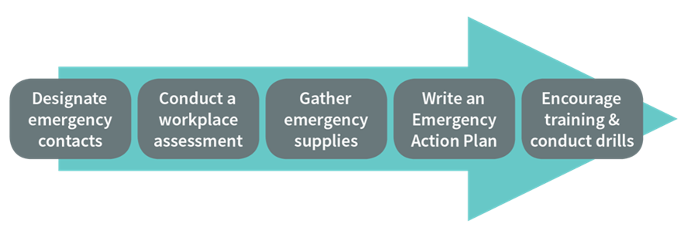

Step #1: Designate emergency contacts

HRMS allows for the assignment of specific emergency preparedness roles for department managers and appointed staff. As a liaison to all other faculty, staff and students, they are a vital part of the WashU preparedness system. There are three potential roles that can be assigned:

- Key Management Contact (KMC)
  - Top decision makers or business representatives for the organization who need to be notified of emergencies impacting business in specific buildings or campus locations
- Building Lab Liaison (BLL)
  - Individuals at the department, division or office/lab level who need to be notified of emergencies impacting business in specific buildings, offices, labs or clinics
- Emergency Preparedness Coordinator (EPC)
  - Team leaders(s) who educate employees and facilitate physical evacuation for a pre-selected group of employees in a location. They ensure accountability of team members and report back through chain of command to WUPD or Protective Services

Department managers should select a minimum of two each, a primary and alternate, for every location in which their department resides. The department’s payroll administrator can then officially designate the emergency contact as such in HRMS. Emergency Preparedness Coordinators should be assigned a group of employees, for whom they are responsible.

A video on how to designate employees to an emergency role in HRMS can be found on the Emergency Management website: https://emergency.wustl.edu/programs/emergency-preparedness-coordinators/.

Step #2: Conduct a workplace assessment

It’s vital for EPCs, in coordination with department managers and employees, to assess and prepare their workplace and facility prior to an emergency to reduce risk and ensure safe practices. Take the following steps when conducting a workplace assessment:
- Identify the location of fire extinguishers and fire alarm pull stations.
  - Discuss how to use each with all employees.
  - Do not block, always allow access to emergency devices
- Identify all evacuation routes and emergency exits.
  - Ensure routes and exits are clear of obstacles, obstructions, and combustible materials.
  - Do not use evacuation routes or emergency exits for storage.
- Backup critical data and sensitive information.
  - Store duplicates in a separate location.
  - Keep computer towers off of the floor to minimize flood damage.
- Identify and prioritize power-dependent functions, operations and equipment.
  - Devise a backup plan if these functions are compromised.
  - Identify the location of emergency power outlets in your area, if any.

- Identify available areas of refuge where persons with mobility issues may wait during a building evacuation or fire alarm.
  - Options may include an enclosed stairwell, an adjoining building, a room with a closed door that is located a safe distance from the hazard, etc.
  - This will help isolate them from the hazard, such as fire or smoke, until emergency responders arrive to assist with their evacuation.

- Identify the best location to shelter during a tornado warning.
  - Choose an interior location, avoiding exterior walls and windows.
  - Ensure the location is accessible and will accommodate all occupants.
- Identify safe rooms where employees can hide during an active shooter incident.
  - Choose rooms with solid doors and simple locking mechanisms, if possible.
  - Avoid rooms with windows or choose rooms that have blinds for concealment.
  - Look for furniture or items to use to barricade entry into the room.
  - Choose a space that does not have automatic lights.
  - Consider how to communicate with public safety officials.

- Identify a room where your employees can shelter-in-place in case of a hazardous materials incident.
  - The room should be near the interior of the building, if possible, and limit exposure to the air outside.
  - Preposition items such as plastic sheeting and duct tape to seal all vent and cracks that may allow air into the room.
  - Allow for access to communication and media for additional updates.
- Secure tall pieces of equipment and furniture to minimize injuries during an earthquake.
  - Secure computers, equipment, and display cases.
  - Store heavy items near the floor.
  - Move tall pieces of equipment away from exits.
  - Anchor bookcases, cabinets and other tall furniture to the wall.
  - Do not stack furniture.
Step #3: Gather emergency supplies
Standard emergency supply kits (Red Bags) are available for purchase by departments. Red Bags are intended for use by the Emergency Preparedness Coordinators (EPCs) to support their departments during an emergency. The kit contains basic first aid supplies, as well as a flashlight, whistle, duct tape and additional response supplies.
You can find information on how to order the emergency preparedness supply kits or to replenish expired supplies through the Emergency Management website, https://emergency.wustl.edu/tools-resources/, or on the WUSTL Marketplace.
Step #4: Write an Emergency Action Plan (EAP)
As a basic outline, there are primarily two categories of emergency plans: Emergency Action Plans and Business Continuity Plans.

- Emergency Action Plans are intended to guide the immediate actions of faculty, staff, students and visitors when an emergency first occurs. These actions occur from the moment there is a hazard impacting the university, or an imminent threat of a hazard, until the immediate threat to life has passed.

- Business Continuity Plans typically activate after EAPs have been implemented and focus on the recovery aspects of the disaster. BCPs consist of two primary phases:
  - quick and temporary resumption of critical, time-sensitive services and operations
  - complete “restoration” of all business functions, returning back to “normal”

Per OSHA standard 1910.38 an emergency action plan must be in writing, kept in the workplace, available to employees for review, and should include, at a minimum:

- procedures for reporting a fire or other emergency
- procedures for emergency evacuation, including type of evacuation and exit route assignments
- procedures to be followed by employees who remain to operate critical plant operations before they evacuate
- procedures to account for all employees after evacuation
- procedures to be followed by employees performing rescue or medical duties
- the name or job title of every employee who may be contacted by employees who need more information about the plan or an explanation of their duties under the plan

An employer must review the emergency action plan with each employee covered by the plan when:

- the plan is developed or the employee is initially assigned to a job.
- the employee’s responsibilities under the plan change.
- the plan is changed.
Step #5: Attend training and conduct drills
An important part of emergency preparedness is taking advantage of available training that may help better prepare for emergencies and disasters. The Washington University Emergency Management department conducts, or promotes, many classes on emergency preparedness. Class descriptions, as well as registration information, are found the emergency management website. Faculty, staff and students may also register directly through Learn@Work. Below is a list of current classes:
- EMGT 2001: Emergency Preparedness Coordinator Training
- EMGT 2002: Annual EPC Refresher
- EMGT 2003: Fire Safety & Extinguisher Training
- EMGT 2004: General Emergency Preparedness
- EMGT 2005: Active Shooter Response Training
- CPR/AED Training (www.fpp.wustl.edu or www.est.wustl.edu)
- R.A.D. Training – Check with WUPD at www.police.wustl.edu

Once employees have attended training and are educated on what the emergency procedures are, department’s should conduct practice drills to apply what they have learned. This could be as simple as picking a time and walking through the procedures with your employees.

- Fire: Practice evacuating the building, clearing your area and accounting for employees at the emergency assembly point.

- Tornado: Have everyone practice walking to your severe weather refuge area and taking cover.

- Active Shooter: Have everyone get into their designated safe room, lock the door and stay quiet for five minutes.

- Earthquake: Have everyone practice getting under a table or desk and taking cover.

